

Internship 2022 Progress report

Name: ADHO MAMO

# Tasks completed last week

## ● [#58] Raspberry Pi and Arduino Uno connection

**Serial communication between Raspberry Pi and Arduino**

Serial communication is simply a way to transfer data. The data will be sent sequentially, one bit at a time (1 byte=8bits), contrary to parallel communication, where many bits are sent at the same time.

**Hardware setup for serial communication**

1. **Serial communication via USB**

To establish serial communication between Raspberry Pi and Arduino, simply connect them with a suitable USB cable. In our case, we use a Raspberry Pi 4 and an Arduino UNO. So we need a USBA Male to USB B Male cable. It is also possible to create serial communication by using the Rx/Tx pins of both components.

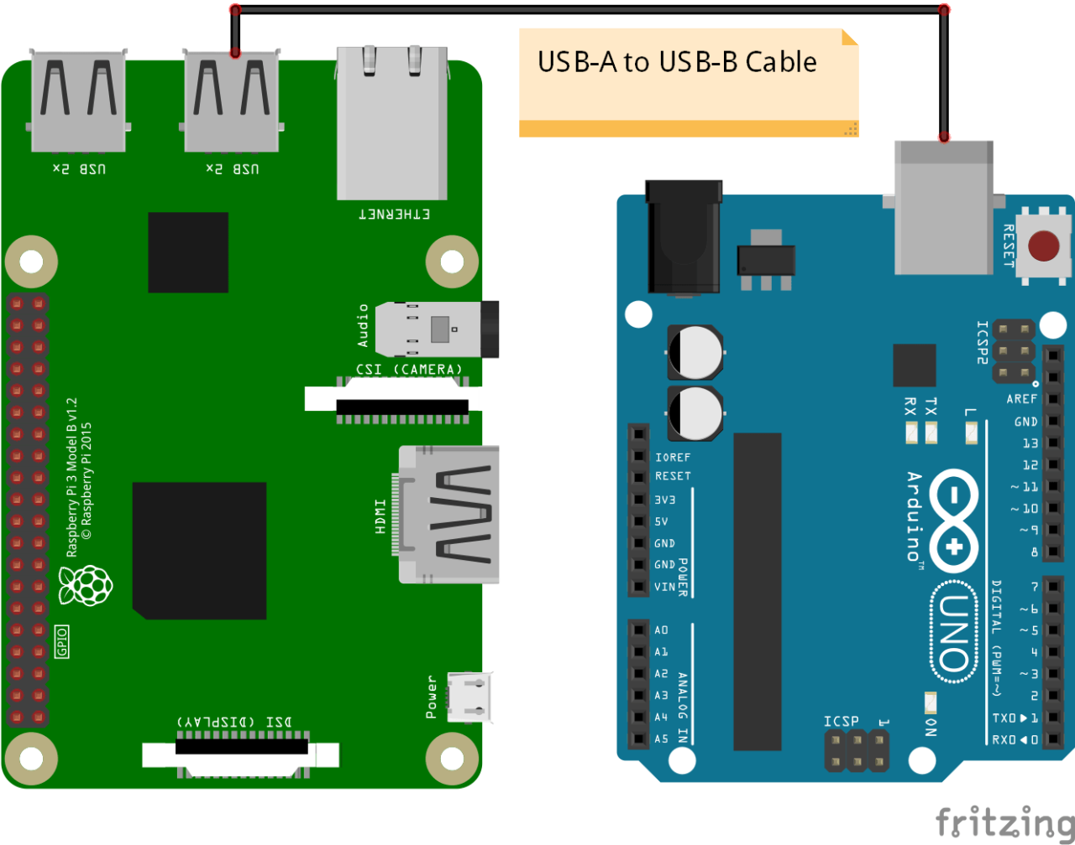

**Note:** you will first need to connect your Arduino to your computer, so you can upload the code into the board. After that, connect the USB cable to the Raspberry Pi. The Raspberry Pi will power the Arduino via the cable.

1. **Serial communication via GPIOs**

To make a serial connection you can also use plain wires between the Raspberry Pi GPIOs and the Arduino pins.

Because there is voltage difference between the two devices on these interface, a voltage divider or logic level converter would be required. Depending on your Arduino board you might need to use a voltage level-shifter. The Raspberry Pi is operating at 3.3V. For Arduino boards like Due, 101, it will be fine because they also use 3.3V. But, for many Arduino, such as Uno, Mega, Leonardo, Nano, and many more, the board is operating at 5V. Thus, you need a 3.3V or 5V level-shifter to protect the Raspberry Pi when connecting RX and TX.

**How to connect using Serial communication**

We know the Arduino Serial library, which allows you to log what is happening in your code and get user input. When you use the Serial monitor, well, basically your Arduino IDE initiates a Serial communication with your Arduino. You can receive and send data directly from the Serial monitor.

What we will do here is almost the same, except that instead of your Arduino IDE, the other side of the Serial communication will be a Raspberry Pi board. We will have to do some setup and write some code to make it work. Then, both Raspberry Pi and Arduino will be able to send messages to each other.

## ● [#59] Running a video feed using webcam and Raspberry Pi

We installed openCV in Raspberry Pi, we also installed python in the Raspberry Pi. We connected the webcam to the USB port in the Raspberry Pi. We have also uploaded the video feed program.

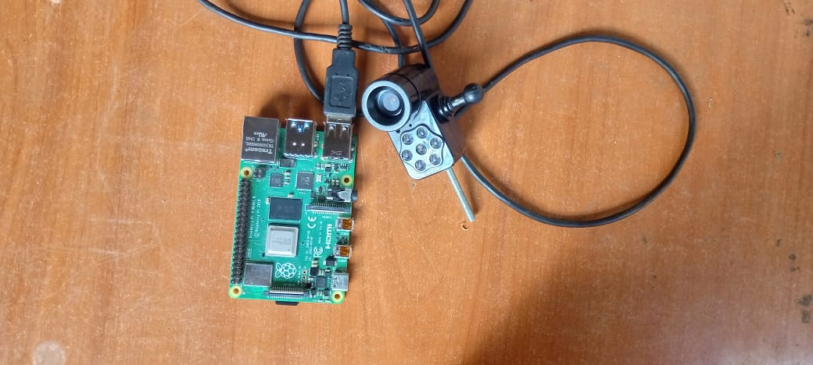

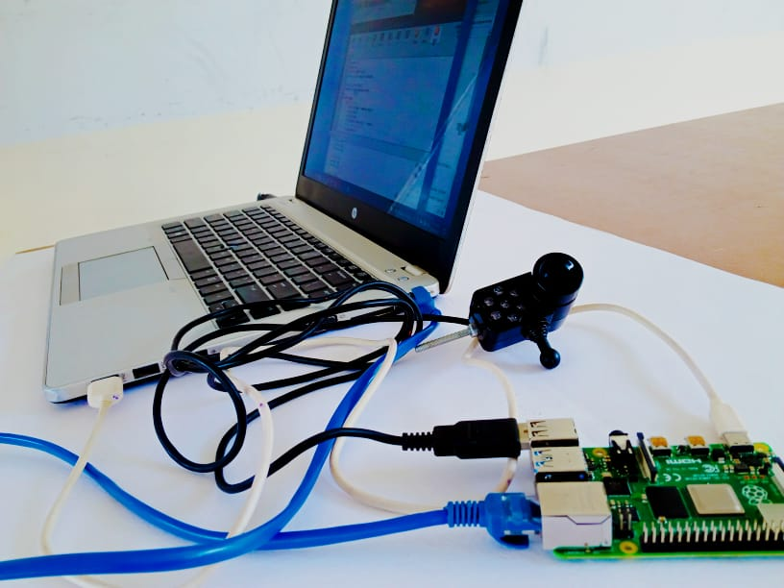

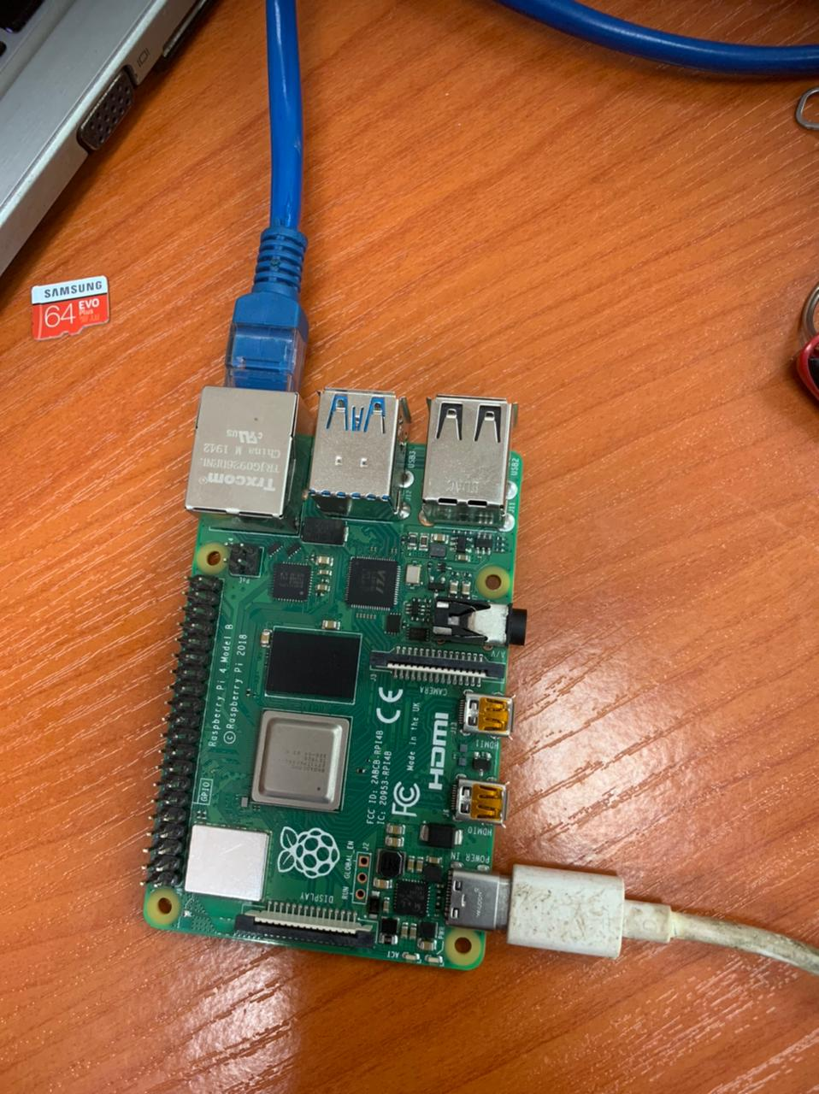

Figure 1Raspberry Pi

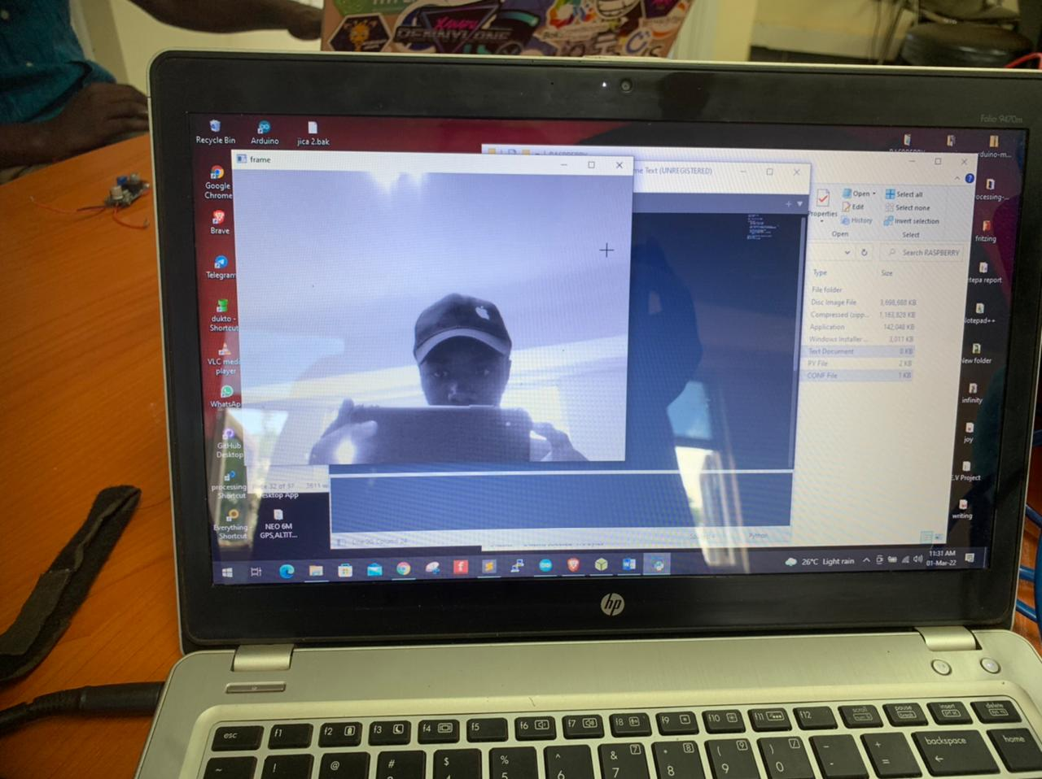

Figure 2Webcam

# Tasks in this week

* [#57] TCP/IP server and client connection

# Timeline

|  |  |  |
| --- | --- | --- |
| Month | Intern week | Tasks |
| Jan |  |  |
| Week 1 | Identification of parts and drawing of the chassis diagram. |
| Week 2 | Circuit diagram and acquisition of parts. |
| Week 3 | Definition of the path to be followed by the robot car.  Laser cutting of the parts. |

|  |  |  |
| --- | --- | --- |
| Feb | Week 4 | * Assembly of the robot * Ultrasonic program implementation |
| Week 5 | * GPS and compass navigation * Path definition |
| Week 6 | Object identification using computer vision. (Raspberry pi & camera) |
| Week 7 | Transmission of live feed and data from the robot  (transmitter and receiver) |
|  | Week 8 | Implementation of tillage program on the robot (gathering and casting). |
|  |  |